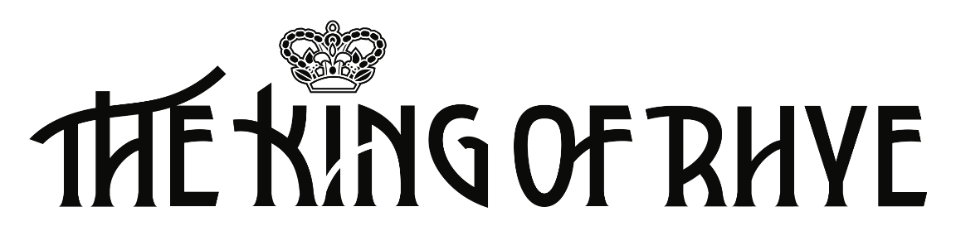

**Songbook**

All lyrics © Craig Mulhall

Except ‘The Hero of Us All’ © Luc Hudson

**A Tale of Rhye (Part 1)**

On the flipside of reality, I found it there

A place of gods and prophets, realms beyond compare

From Sontenan to Petrichor

The Vultan Peaks to Nevermore

The curse that lay upon it spoke of grave despair.

The wise old man Khashoggi, he did prophesise

A tempest would destroy that land, from deathly skies

Flood and plague and mountains quake

The ring of Oberon shall break

The ancient gods will clash and Valendyne shall rise…

**The Wearers**

Brown are Neophytes, Apprentices of highest potential

Gold are Elementals, towards nature and beast deferential

Green are Apothecaries, brewing elixirs for wellness and health

Sky Blue are Sorcerers, casting charms for fortune and wealth

Deep Blue are Astrologers, reading omens in the stars

Violet are Warlocks, indomitable fighters of wars

Black were Necromancers, who… [erased from record and memory]

Scarlet are Mages, many Disciplines conquered with grace

White is the Archimage, Lord of the Adept, first of his race.

**The Song of the Prophet**

Land of Rhye, Light of the World

Born at schism of Night and Day

Praised your bounty and blessed your kin

Mighty Seas at your shores do pray.

A doom it comes, the endless dark

Flood and plague from wretched keep

The earth will shake from wrath within

Beware: the storm brings eternal sleep.

A white shroud laid upon the land

Death will stalk while the elders wait

The Lords of old will crumble hence

The youthful cry but flee too late.

This fateful night I stand on high

The moon it swells and shows my place

This Song I give, for songs may save

Evil purged with hymnal grace.

Water, Fire, Earth and Air

Each one will sing and march with fate

But Love is key to kingdom come

A cure, a paean, a song does wait.

From love estranged does new love grow

Across the Seas, the answer found

Fly and find, and thence return

To peace and fortune all around.

O King of Rhye, redeem our land

With sacred ore both still and swift

I know you hear me – take my hand

The throne awaits: a blessed gift.

**Lady Maybeth’s Lament**

As northern winds grow colder

It takes me to that place

I won’t see when I’m older

The etchings on your face

Blessed be Ophynea

Her promises were true

Forbidden were those bitter nights

When I lay close to you

The pangs of duty turned me

For Realm a union made

This tower now I call my home

Forever I’m afraid

The pact I keep with Lhestra

The King of Rhye shall stand

One eldritch word can liberate

Love yet may save the land.

**A Tale of Rhye (Part 2)**

For the April Lady came to us with an ardent song

That says from love does new love grow

Across the Seventh Sea we know

A bid for peace and fortune forever long

The dawning of your Sovereign Age is nigh

It will be borne in sacrifice

A hero’s life shall be the price

A sacred legacy to hold on high

**The Hero of Us All**

Mystery man

Fae with a flight of fancy and a master plan

Raised in the Vale of Plenty where winged horses ran

You flew along

You’ll raise the dead, come along she said … and she wasn’t wrong

And so, it came to pass

Boy with a dream to save the world from the dark morass

Love of a band of brothers who were unsurpassed

You knew the song

You’ll save us all but you have to fall … and you must be strong

The hero (love)

The hero (fly)

The hero (he’s)

The hero of us all

A killer Queen

In it to save herself with a smile for a broken dream

Beguiling and dangerous the enchantress in high esteem

Strung him along

She’ll determine the fate of the populace … if he can’t hold on

Fly high little hero, it’s only bound before it breaks

You don’t have to worry, true love is all it takes

Just let me in

**A Tale of Rhye (Part 3)**

In the shadow of the Mountain, the war it now begins

The two-way mirror shows us catastrophic things

The Black Queen and the White shall clash

Ogres fight ‘neath lightning flash

In Nevermore a duel of gods and kings…

**Sweet Dirge**

The forest must burn

The Yew must fall

The Fairy King must die

In the name of the Black Queen … fie!

**The Dark March**

Hark! Lo, the Black Queen

Heart of Valedyne

She’ll take us to the kingdom come

Her majesty divine

She’s our leader!

She who brings our Lord back to Rhye

To join the God of War

(He rides the manticore)

Fear the graceless, taunt the faithless – fie!

Hi-ho, the Black Queen

Wrath and thunder-fire

She riles and defiles and she’ll rule the land entire

You can’t beat her!

Valendyne breaks free from the Ring!

His bonds in Nevermore can’t hold him anymore

Reap the farrows, charge the narrows – fly!

**Ode to Love**

Fly my dearest Mustapha, all hope now rests with you

Remember there’s a purpose behind everything you do

The Prophet spoke of love to save the land and sea and sky

Love abounds within your soul – a paragon for Rhye.

The hopes of every precious soul, a vessel fine will be

To buoy you on your gallant way across the Seventh Sea.

To distant shores, to places new, a prophecy foretold

Keep your spirit bright and true – may fortune grace the bold.

My heart you stole, my life upturned

All through these days, for you I’ve yearned

I’d follow you to Rhye’s new dawn

But now I wait – return anon.

Go now on your vital quest, on angel wings take flight

Deliver love, a saving grace beyond the speed of light

With every beat my heart does sing, my strength to you I send

Remember I am there with you until the very end.

**Long Live the King … Revisited**

Can a season change without the fall of autumn leaves?

Can a baby born asleep know how her mother grieves?

And so, it goes

We live in hope both day and night

We pray in darkness and in light

That the wonders of our world may be renewed.

Does tomorrow weep when we choose sides and go to war?

Black or white, it’s in our veins – what do we do it for?

Nobody knows

Love your father, bless your mother

Without love there is no lover

Tomorrow’s legacy, it rests with you

With joyous hearts we will sing along

Long live the King, long live the King

And may your reign be forever long

Long live the King, we say long live the King

Beseech the Sun, entreat the Moon, embrace the stars above

A prophecy made real today – this gift is born of love

I make my wish, a dream come true, I name the gods on high

The miracle within my heart – to save the land of Rhye

Now the pall of death is cast aside with choral prayer

Ophynea did anoint my brow with fire’s cleansing flare

Her glory shows

In blessed skies a mystery; the grandest dance in history

A new day dawns and Rhye is born anew.

**A Tale of Rhye (Part 4)**

On the flipside of reality, I found it there

A place of gods and prophets, tales beyond compare

From Nurtenan to Warnom Bore

Mages Pass to the Dunes of Sordd

The curse that lay upon it spoke of grave despair

In solemn tones I bid farewell, my tale now is done

The fate of Rhye may yet be told – this song is sung

The Fairy Feller is my name

My axe has brought me widespread fame

I make my master stroke tonight – please come.

**End of Songbook**